**Name: G. Ganesh**

**Reg No:192373008**

**CSA1611**

**Data Ware Housing and Data Mining For Decision Support**

**Day 01**

**lab programs-R programming**

**EXPERIMENT-1**

**ADDITION:**

**AIM:**

**To prove the program for addition using R-tool.**

**PROGRAM:**

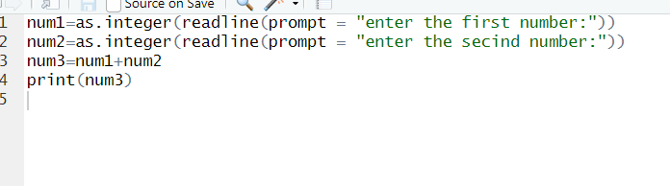

**OUTPUT:**

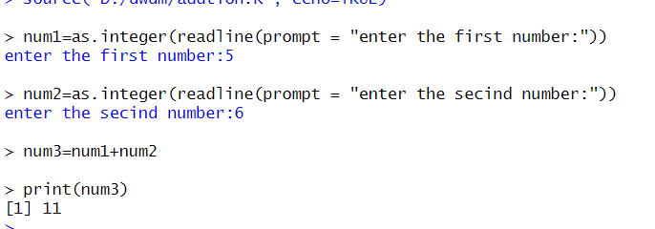

**RESULT:**

**Thus the basic program addition are executed successfully.**

**EXPERIMENT-2**

**SUBTRACTION:**

**AIM:**

**To prove the program for subtraction using R-tool.**

**PROGRAM:**

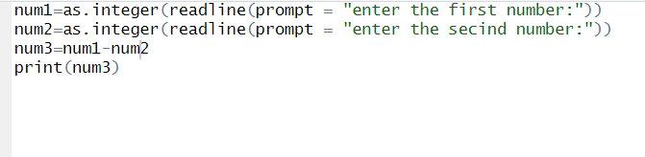

**OUTPUT:**

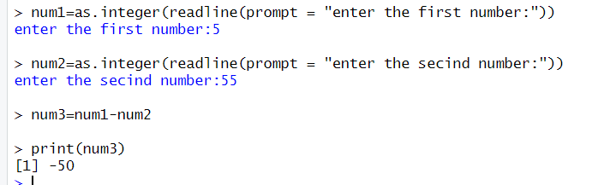

**RESULT:**

**Thus the basic program subtraction are executed successfully.**

**EXPERIMENT-3**

**MULTIPLICATION:**

**AIM:**

**To prove the program for multiplication using R-tool.**

**PROGRAM:**

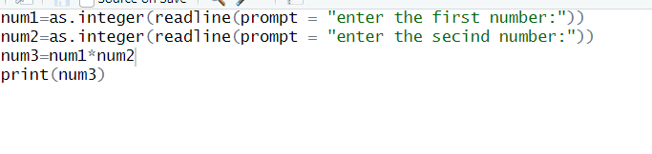

**OUTPUT:**

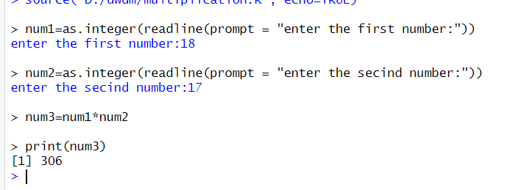

**RESULT:**

**Thus the basic program multiplication are executed successfully.**

**EXPERIMENT-4**

**DIVISION:**

**AIM:**

**To prove the program for division using R-tool.**

**PROGRAM:**

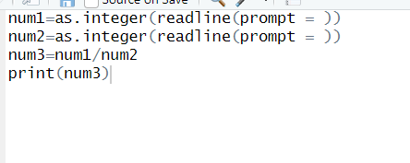

**OUTPUT:**

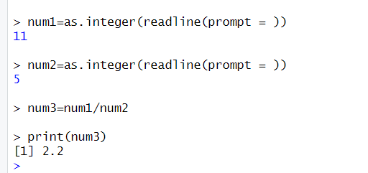

**RESULT:**

**Thus the basic program division was executed successfully.**

**EXPERIMENT-5**

**ODD OR EVEN:**

**AIM:**

**To write the program for odd or even using R-tool.**

**PROGRAM:**

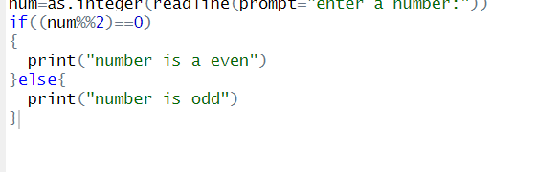

**OUTPUT:**

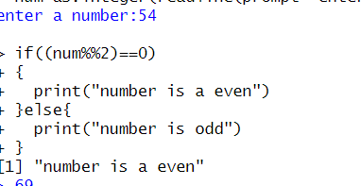

**RESULT:**

**Thus the basic program odd or even was executed successfully.**